1. **Laptop Price Tag Generator**

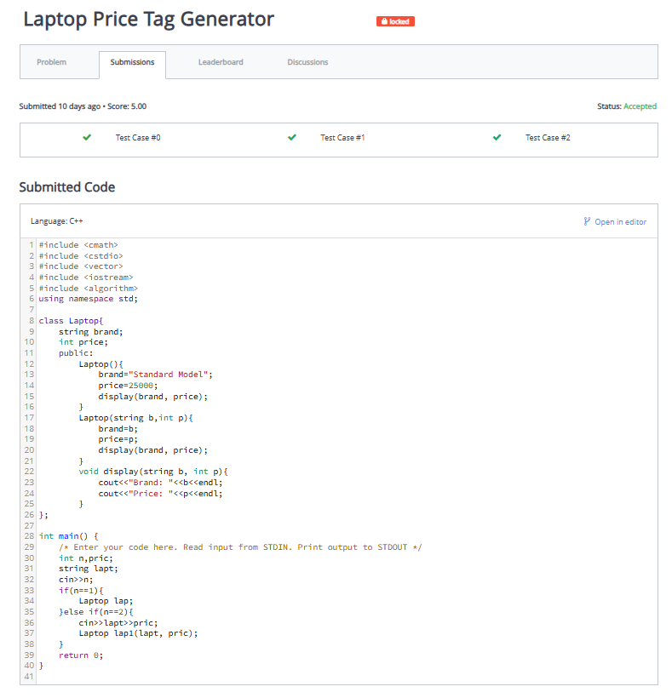

1. **Movie Ticket Calculation System Detai**

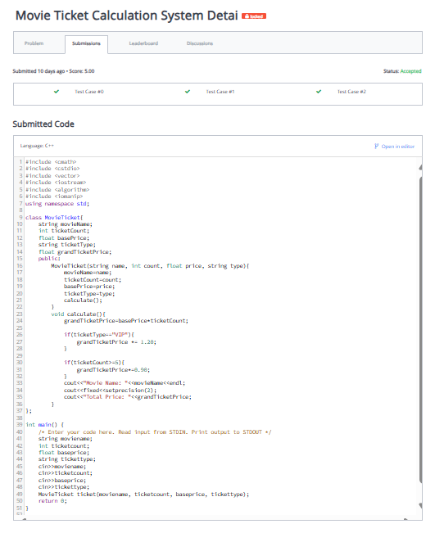

1. **Mobile Recharge Simulator**

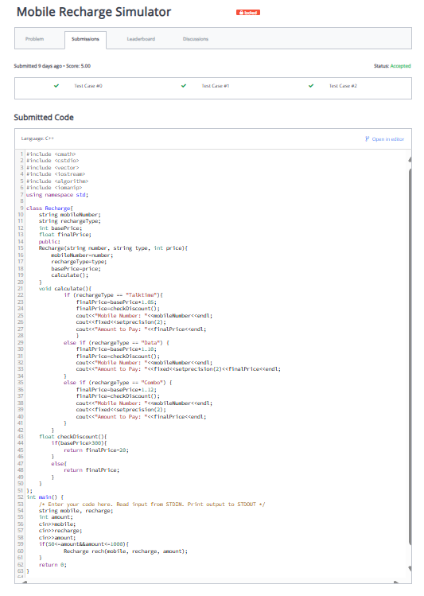

1. **Box Volume Calculator**

1. **Bank Loan EMI Calculator**

1. **City Weather Report**

